**EC5020**

**LAB 02 – DIGITAL MODULATION**

**WIJEDASA M.M.D.P.**

**2021/E/188**

**CG17**

**SEMESTER V**

**07th AUGUST 2024**

* **PART 2 – AMPLITUDE SHIFT KEYING PART**

**2(a) – MODULATION**

**AIM:**

• To grasp the signal waveform of an Amplitude Shift Keying (ASK) modulator.

• To construct an ASK modulator using the MC 1496 integrated circuit.

**PROCEDURE:**

1. The ETEK DA-2000-06 circuit was set up.
2. The necessary power supplies were connected.
3. The signal generator was configured to produce a 5 Vpp amplitude, 2.5 V offset, and 100 Hz frequency square wave signal.
4. The signal generator was connected to the data signal input terminal.
5. The signal generator was also set to produce an 800 mVpp amplitude and 20 kHz frequency sinusoidal wave.
6. The output terminal was connected to the oscilloscope.
7. VR1 was adjusted to eliminate distortion in the output signal.
8. VR2 was then adjusted to correct any asymmetry in the output signal.
9. The output signal waveform was observed on the oscilloscope.
10. The data signal frequency was varied, and the process was repeated.
11. The data signal frequency was reset to 1 kHz.
12. The carrier signal frequency was changed, and the procedure was repeated.
13. The data signal frequency was restored to 1 kHz, and the carrier signal frequency was set to 100 kHz.
14. The amplitude of the carrier signal was adjusted, and the procedure was repeated.

**RESULTS:**

Fig 1:

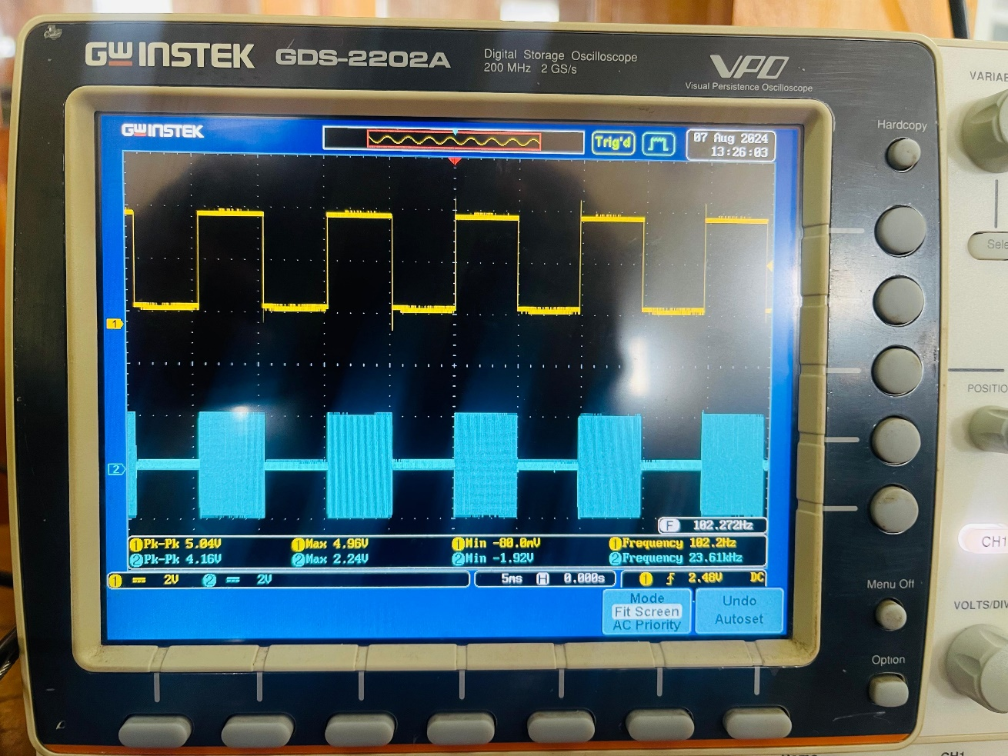

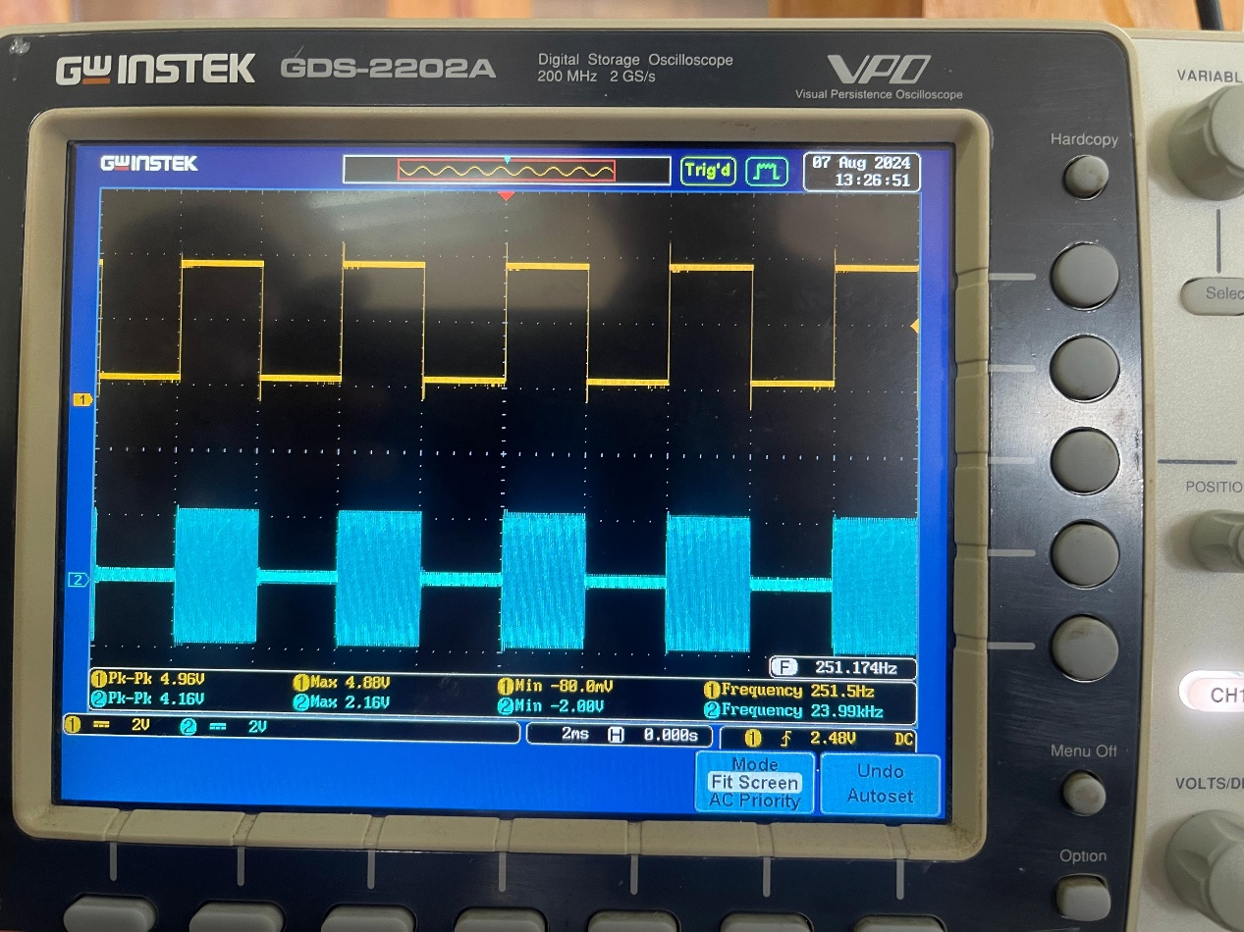fig 2:

Figure 2

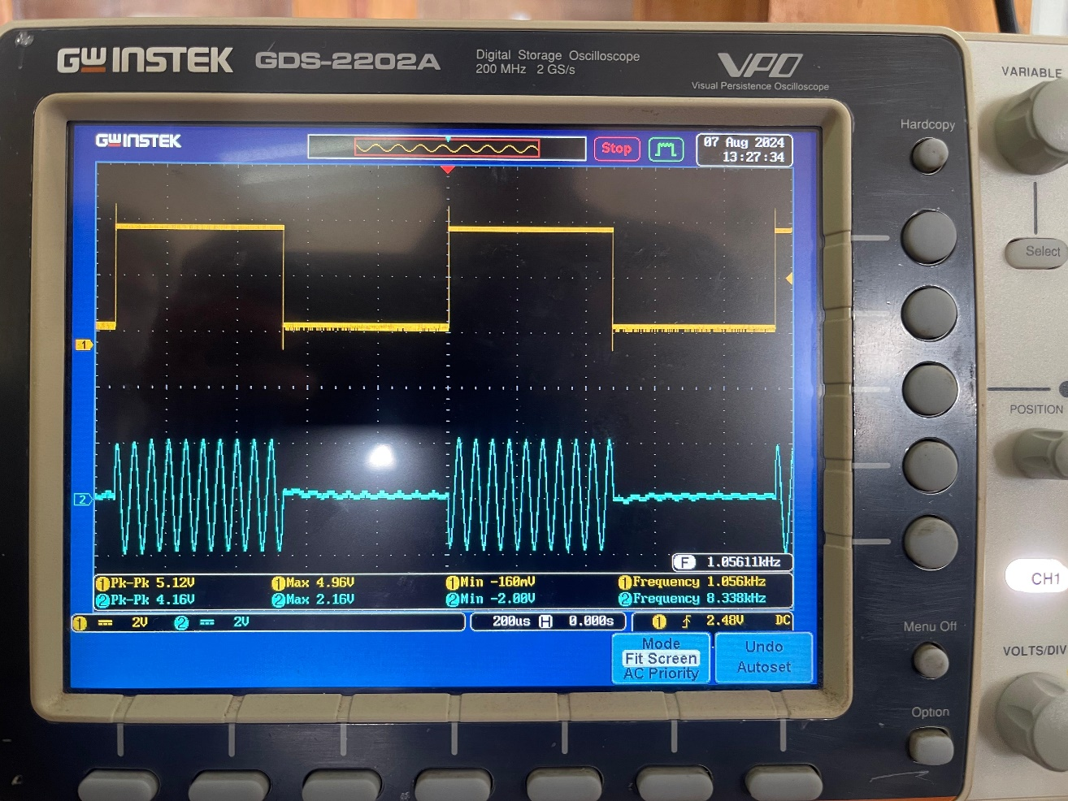

Figure 3

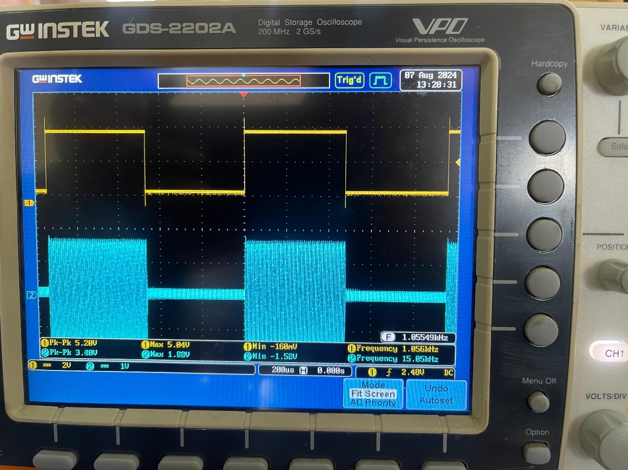

Figure 4

* **PART 2(b) – DEMODULATION**

**AIM:**

• To understand how an Amplitude Shift Keying (ASK) asynchronous detector works.

• To build an ASK demodulator.

**PROCEDURE:**

• An ASK modulated signal was generated using a 100 Hz data signal and a 20 kHz carrier signal with the ASK modulator.

• The output terminal of the ASK modulator was connected to the input terminal of the ASK demodulator.

• The oscilloscope was set to DC coupling mode, and the output terminal of the ASK demodulator was connected to the oscilloscope.

• VR1 was adjusted to achieve the optimal shape of the output waveform.

• The output signal waveform was observed.

• The data signal frequency in the ASK modulator was changed, and the process was repeated. The data signal frequency was then reset to 100 Hz and the carrier signal frequency to 100 kHz.

• The carrier signal frequency in the ASK modulator was adjusted, and the procedure was repeated.

**RESULTS:**

OUTPUT SIGNAL

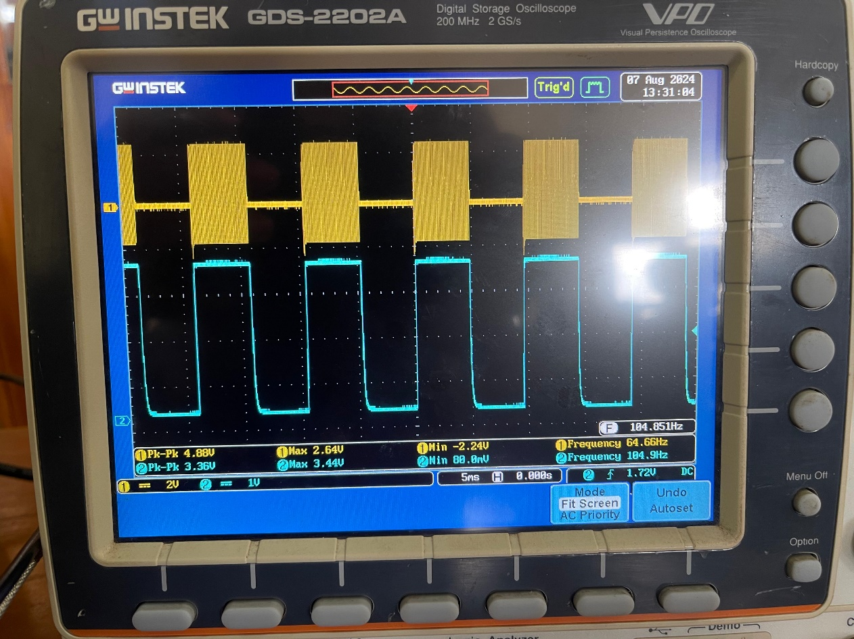

Figure 5

* **PART 3 – FREQUENCY SHIFT KEYING**

**PART 3(a) – MODULATION**

**AIM:**

• To understand how a Frequency Shift Keying (FSK) modulator operates.

• To build an FSK modulator using a Voltage-Controlled Oscillator (VCO).

**PROCEDURE:**

• The ETEK DA-2000-07 circuit was set up.

• The power supply was adjusted to 5 V and connected to the input terminal of the FSK modulator.

• The oscilloscope was connected to the VCO output terminal (pin 3 of the LM 566).

• VR2 was adjusted to set the output signal frequency to 870 Hz.

• The oscilloscope was then connected to the output terminal of the FSK modulator, and the waveform was observed.

• The ground and input terminal were shorted (i.e., 0 V input).

• The oscilloscope was reconnected to the VCO output terminal (pin 3 of the LM 566).

• VR1 was adjusted to set the output signal frequency to 1370 Hz.

• The oscilloscope was then connected to the output terminal of the FSK modulator, and the waveform was observed.

• The signal generator probe was connected to the TTL/CMOS terminal of the signal generator, and the frequency was set to 200 Hz.

• The signal generator was connected to the data signal input terminal of the FSK modulator.

• The input signal, the output signal at the VCO output, and the output signal at the FSK modulator were observed.

• The frequency of the signal generator was changed to 900 Hz, and the procedure was repeated.

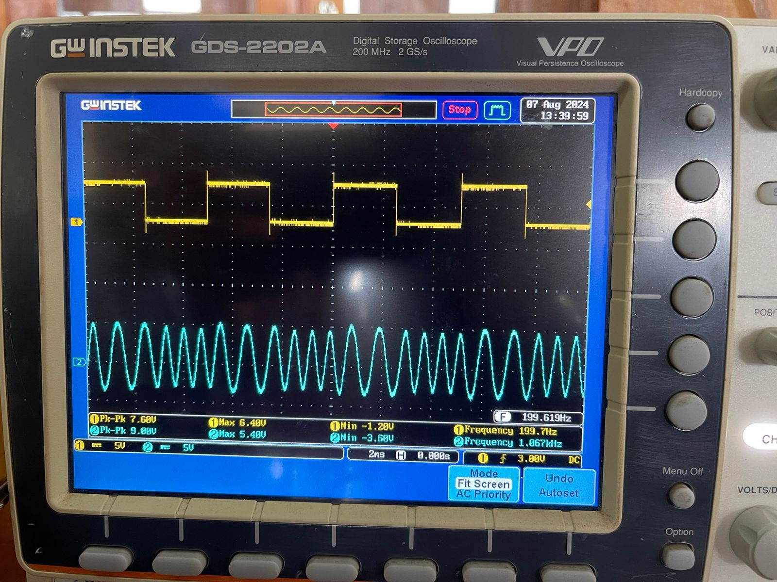**RESULTS:**

Figure 6

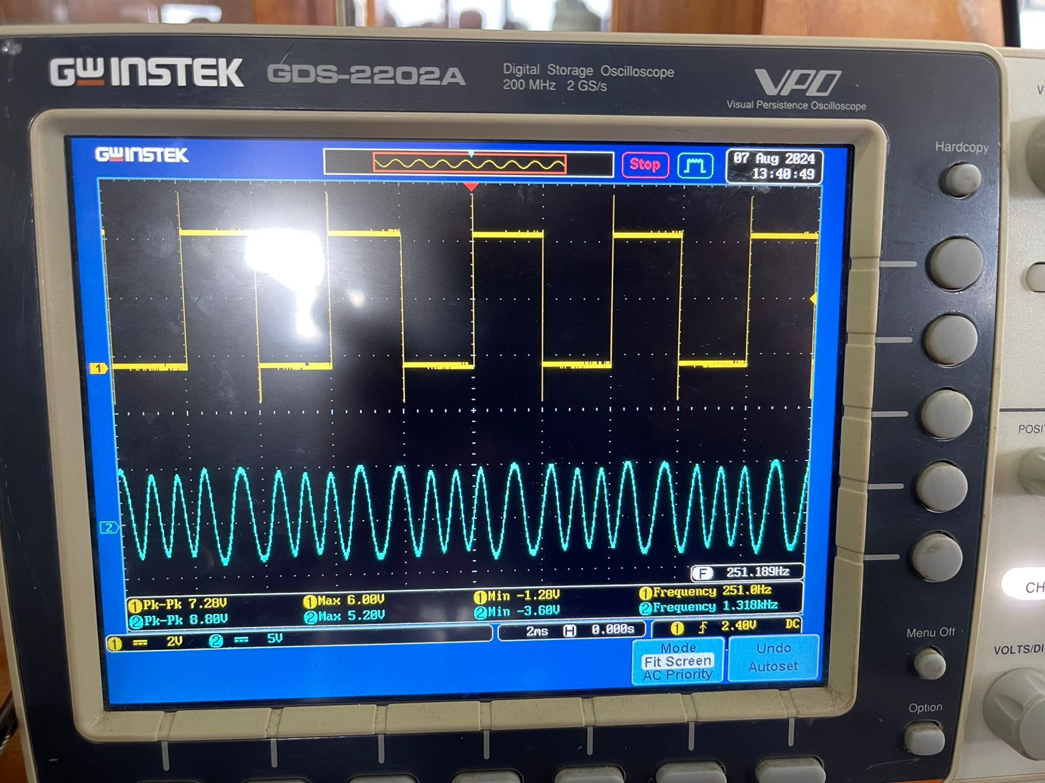

Figure 7

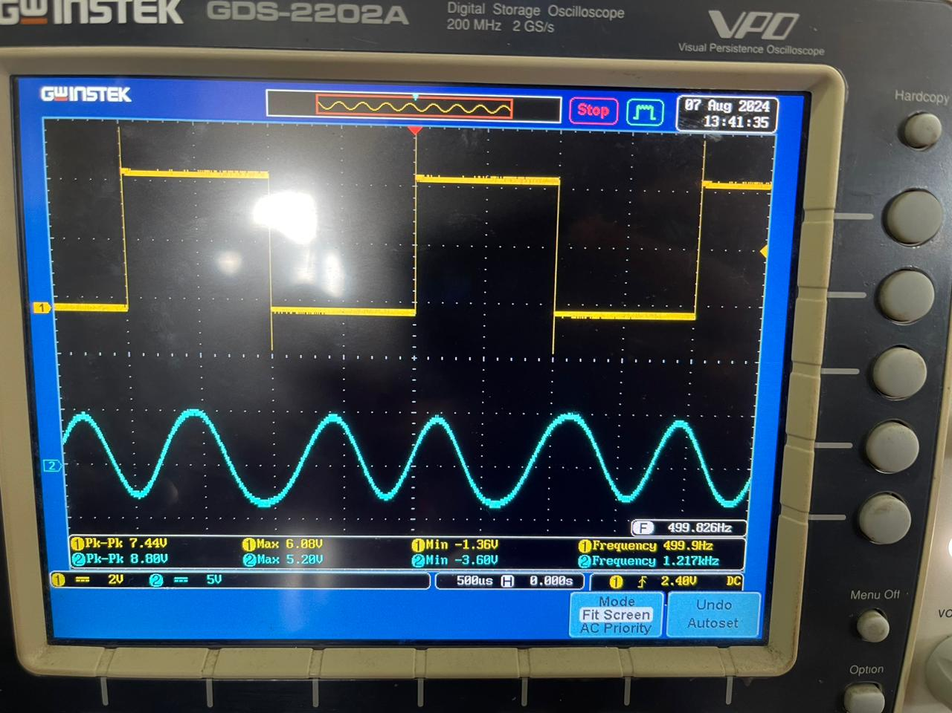

Figure 8

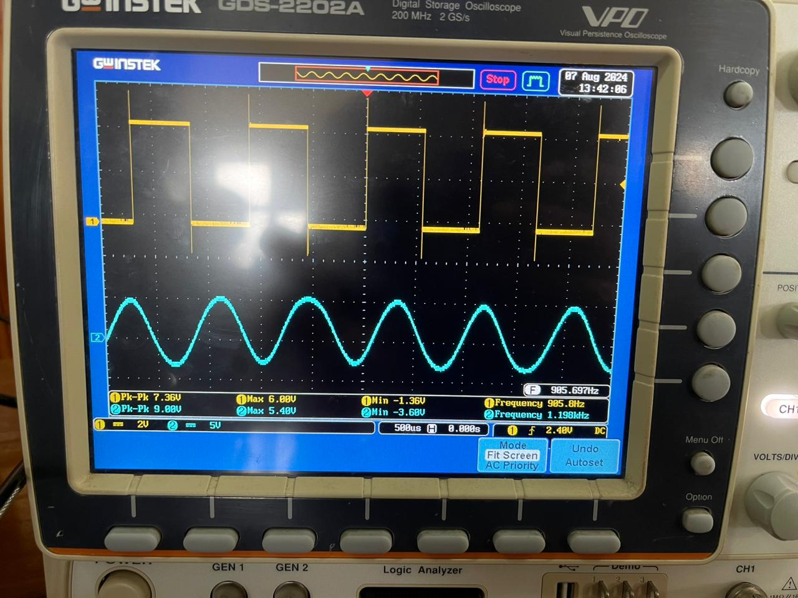

Figure 9

* **PART 3(b) – DEMODULATION**

**AIM:**

* To implement the FSK detector using PLL.

**PROCEDURE:**

1. The ETEK DA-2000-07 circuit was set up.
2. Without applying any input to the demodulator, the waveform at T1 was observed using an oscilloscope.
3. VR1 was adjusted to set the free-running frequency to 1170 Hz.
4. The signal generator was configured to produce an 8 Vpp amplitude sine wave with a frequency of 870 Hz.
5. This signal was connected to the input terminal of the demodulator.
6. The oscilloscope was switched to DC coupling mode and connected to the output terminal of the demodulator.
7. The output signal waveform was observed.
8. The signal generator was then set to produce an 8 Vpp amplitude sine wave with a frequency of 1370 Hz.
9. The output signal waveform was again observed.
10. An FSK modulated signal with a 150 Hz data signal frequency was generated.
11. The output of the FSK modulator was connected to the input terminal of the FSK demodulator.
12. The oscilloscope was switched to DC coupling mode, and the output terminal of the FSK demodulator was connected to the oscilloscope.
13. The output signal waveform was observed.
14. The data signal frequency was then changed to 200 Hz, and the procedure was repeated.

.

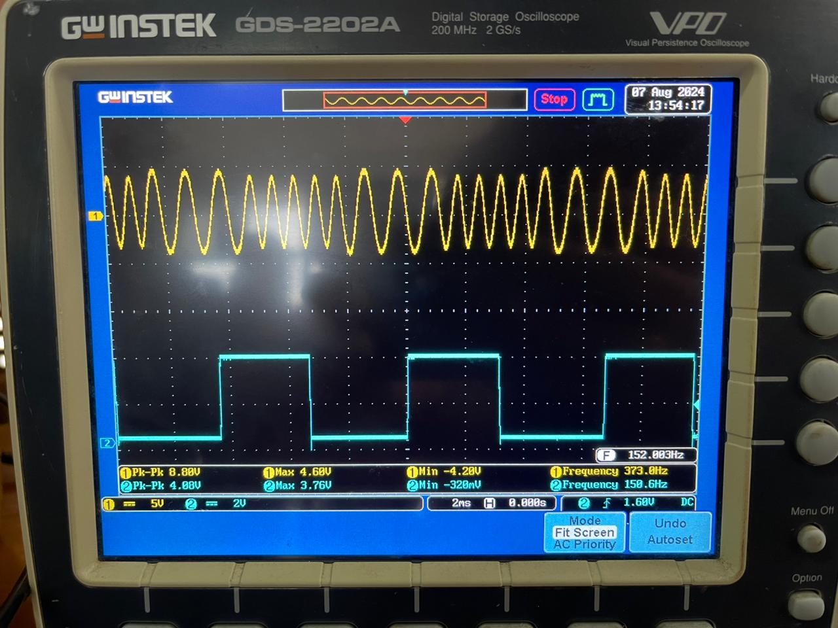**RESULTS:**

Figure 10

* **PART 4 – PHASE SHIFT KEYING**

**PART 4(a) – MODULATION**

**AIM:**

• To understand the signal waveform of a Phase Shift Keying (PSK) modulator.

• To build a PSK modulator using the MC 1496 integrated circuit.

**PROCEDURE:**

1. The ETEK DA-2000-08 circuit was set up.
2. A 5 Vpp amplitude, 2.5 V offset, and 100 Hz frequency square wave was configured on the signal generator.
3. This signal was connected to the modulation signal input terminal.
4. The oscilloscope was connected to terminal T1.
5. The waveform at T1 was observed on the oscilloscope.
6. The frequency of the signal generator was adjusted, and the procedure was repeated.
7. The signal frequency was reset to 100 Hz.
8. The duty cycle of the signal was adjusted, and the procedure was repeated.
9. A 5 Vpp amplitude, 2.5 V offset, 100 Hz frequency, and 50% duty cycle square wave was set on the signal generator.
10. This signal was connected to the modulation signal input terminal.
11. An 800 mVpp amplitude and 20 kHz frequency sinusoidal wave was set on the signal generator.
12. This sinusoidal signal was connected to the carrier signal input terminal.
13. The oscilloscope was connected to the output terminal.
14. VR1 was adjusted to eliminate distortion in the output signal.
15. VR2 was adjusted to correct any asymmetry in the output signal.
16. The output signal waveform was observed.
17. The frequency of the carrier signal on the signal generator was changed, and the procedure was repeated.
18. The modulation signal frequency was reset to 100 Hz, and the carrier signal frequency was set back to 20 kHz.
19. The amplitude of the carrier signal was adjusted, and the procedure was repeated.
20. The carrier signal amplitude was reset to 800 mVpp.
21. The duty cycle of the data signal was modified, and the procedure was repeated.

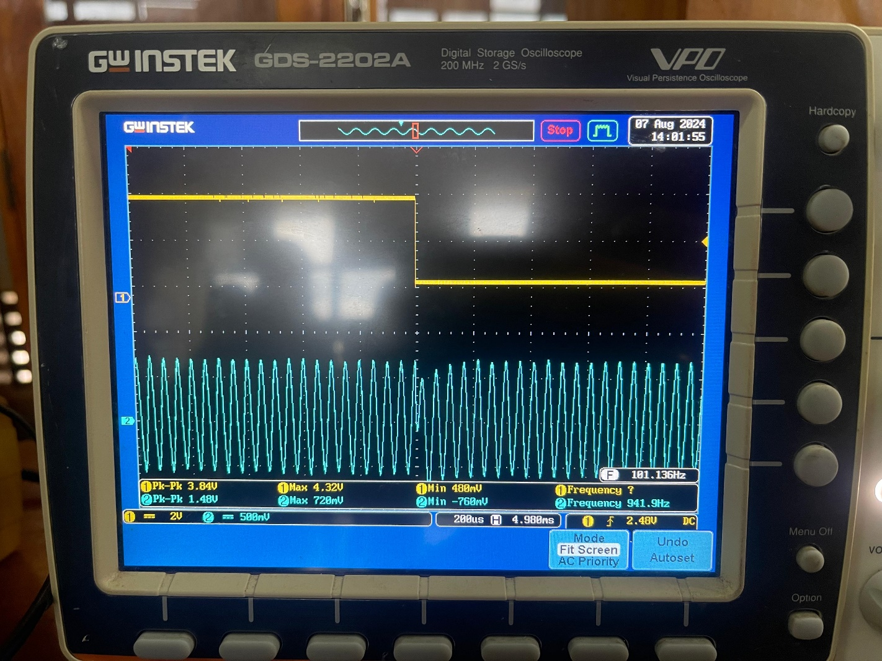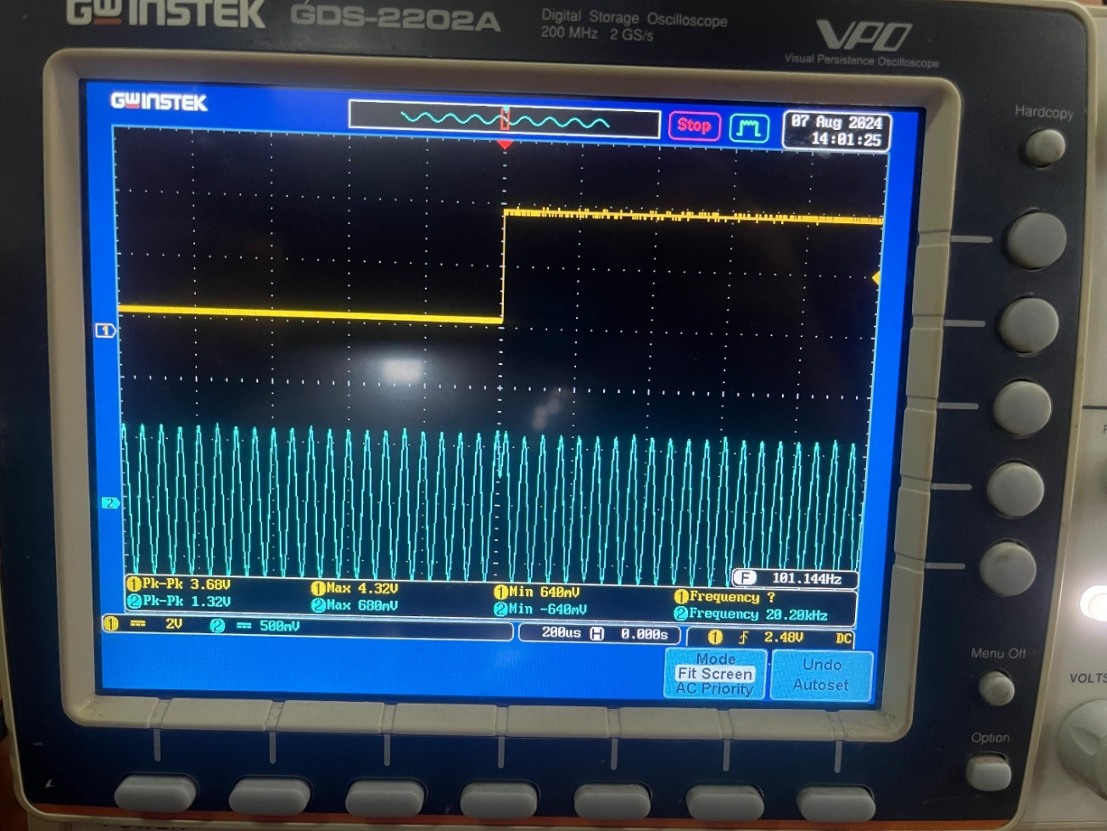**RESULTS:**

Figure 12

Figure 11

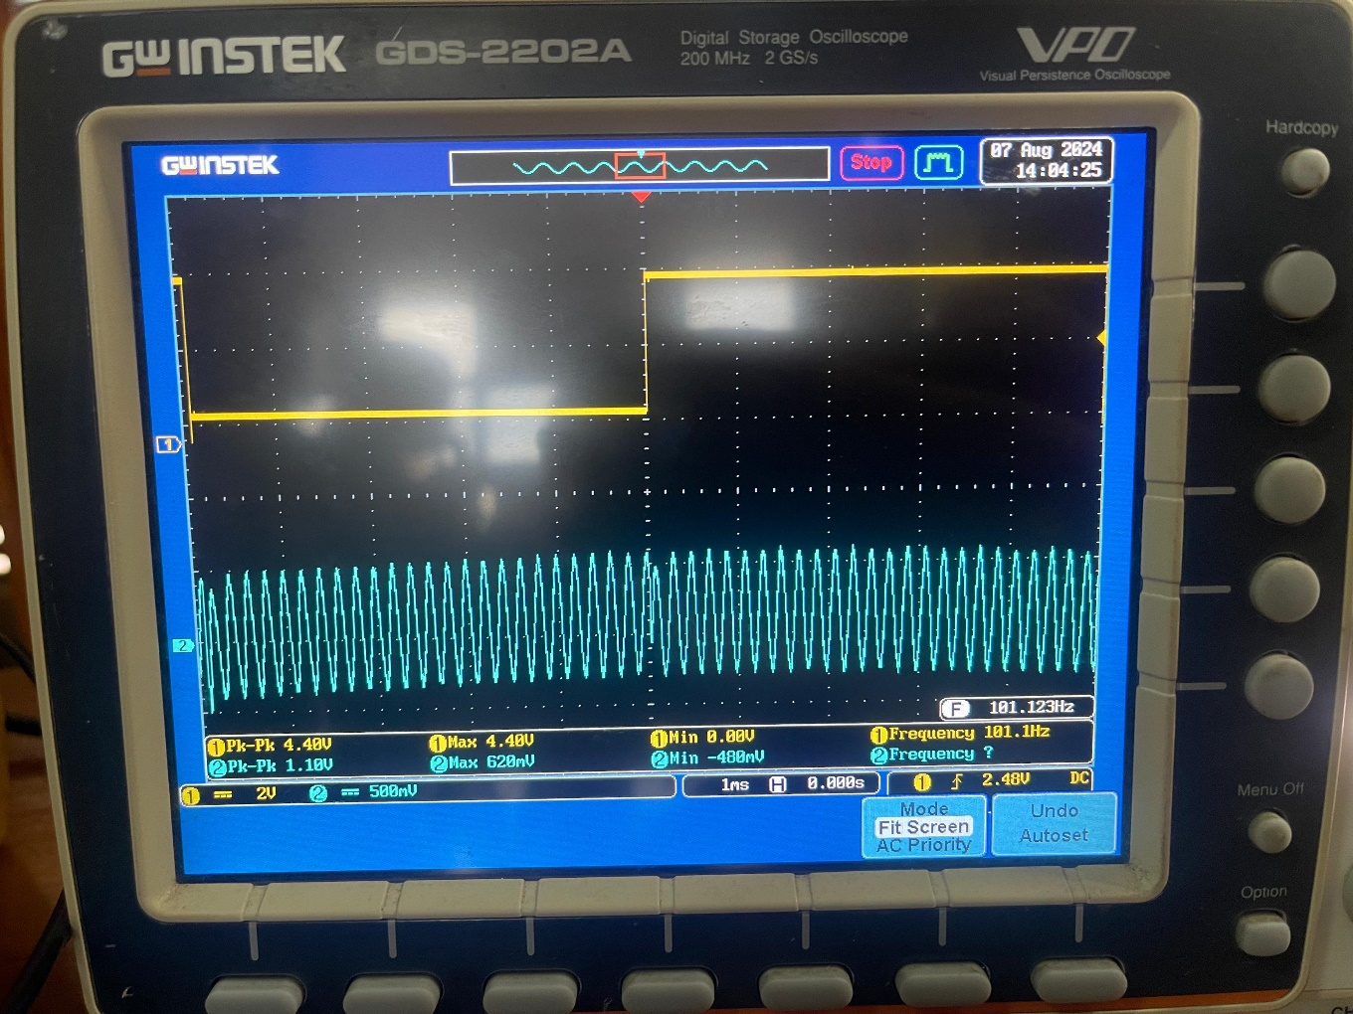

Figure 13

* **PART 4(b) – DEMODULATION**

**AIM:**

* To build a PSK demodulator using the MC 1496 integrated circuit.

**PROCEDURE:**

1. A PSK modulated signal was generated with a 5 Vpp amplitude, 2.5 V offset, 50% duty cycle, 100 Hz frequency square wave for the data signal, and a 1.2 Vpp amplitude, 20 kHz frequency sinusoidal carrier signal.
2. VR1 and VR2 in the modulator were adjusted to remove asymmetry and distortion in the output.
3. The oscilloscope was connected to test point T2.
4. VR2 in the demodulator circuit was adjusted so that the free-running frequency of the output signal from T2 was set to 40 Hz.
5. The output of the PSK modulator was connected to the input terminal of the PSK demodulator.
6. The oscilloscope was connected to test point T1 in the demodulator.
7. VR1 was adjusted so that the frequency of the signal was twice the carrier frequency (40 kHz, where the carrier frequency was 20 kHz).
8. VR3 was adjusted to ensure the demodulated signal was correct.
9. The oscilloscope was connected to the input terminal, test points T1, T2, T3, and the output terminal of the demodulator in sequence.
10. All the waveforms were observed.
11. The data signal frequency was changed, and the procedure was repeated.
12. The data signal frequency was restored to 100 Hz.
13. The duty cycle of the signal was adjusted, and the procedure was repeated.

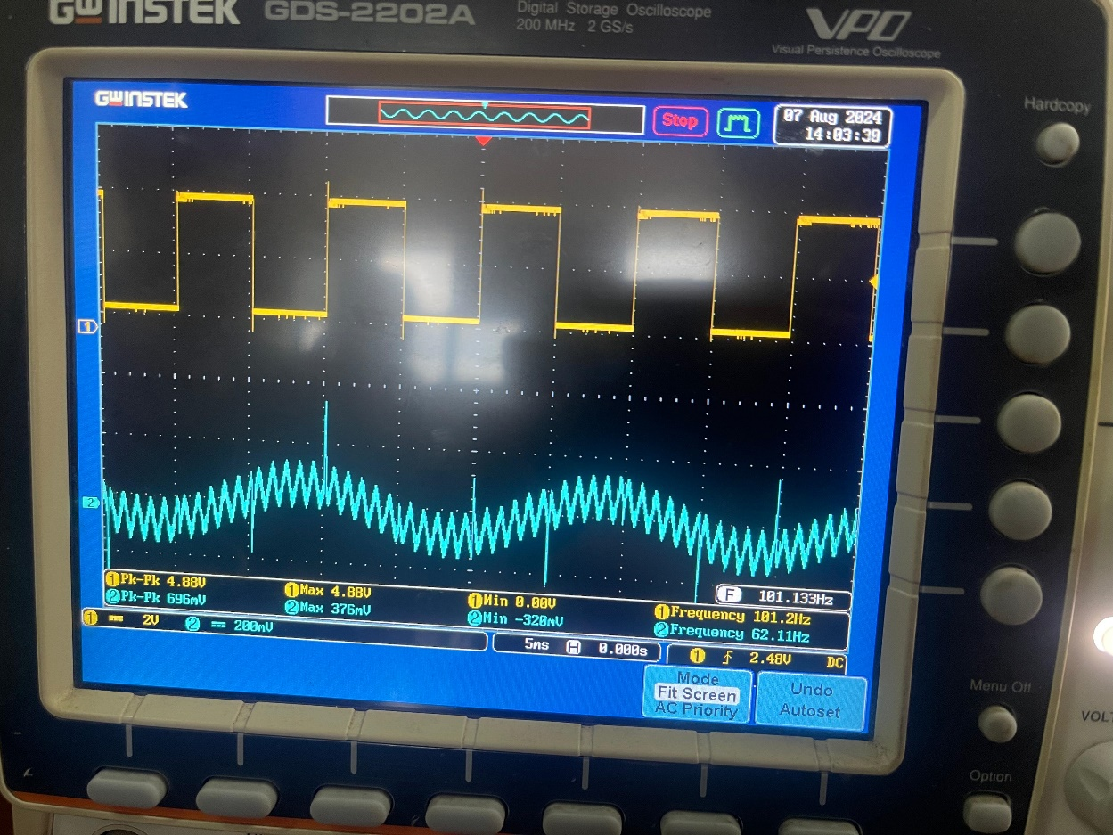**RESULTS:**

Figure 14

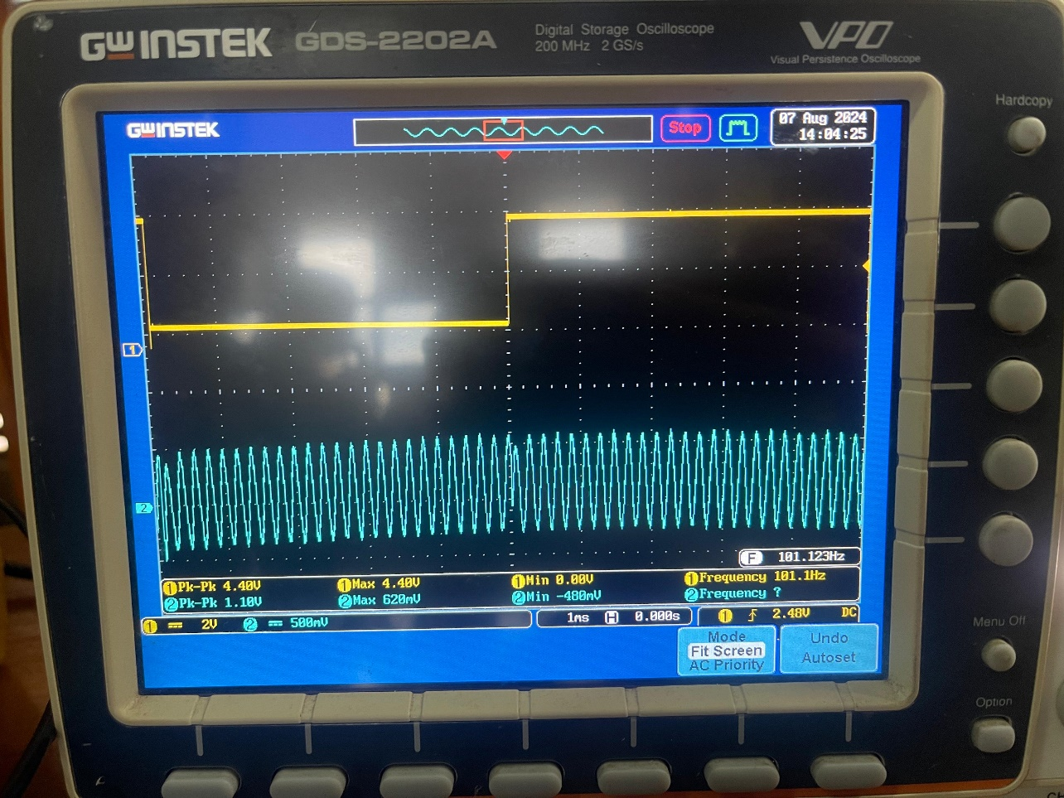

Figure 15\

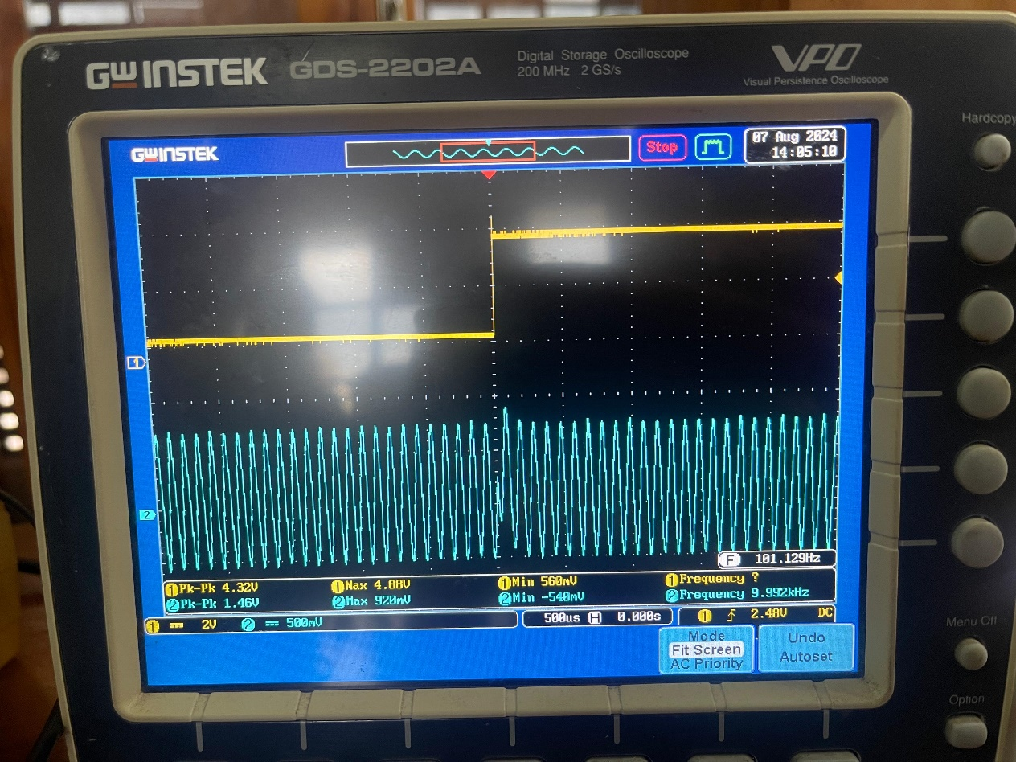

Figure 16

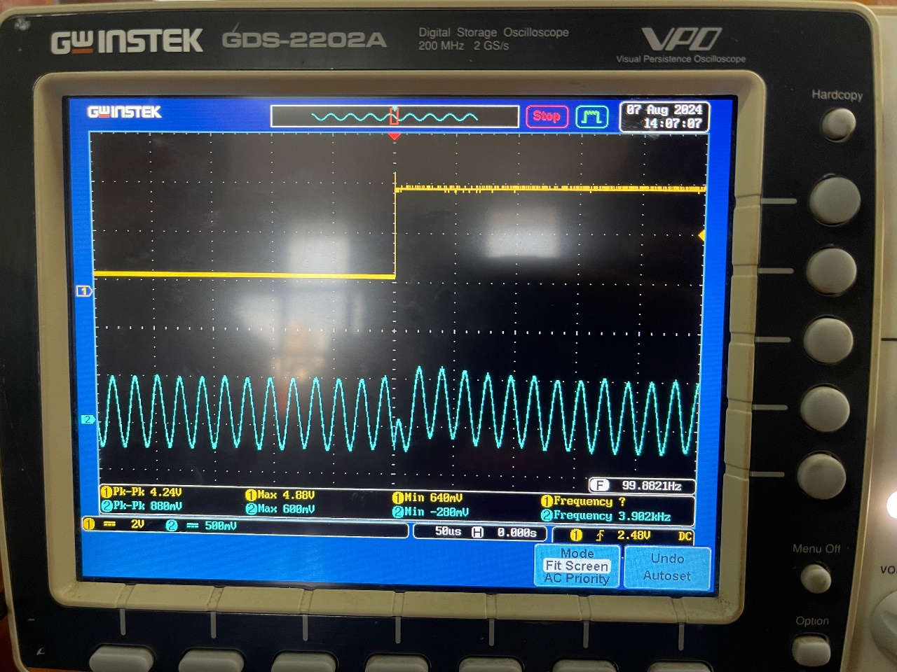

Figure 17

**DISCUSSIONS:**

1. **Compare the advantages and disadvantages in each modulation scheme.**

1. Pulse Width Modulation (PWM)

**Advantages:**

* **Efficiency:** PWM is very efficient for power delivery, especially in digital circuits and motor control.
* **Noise Immunity:** Less affected by noise since information is encoded in the width of pulses rather than amplitude.
* **Simplicity:** Relatively simple to implement in circuits.

**Disadvantages:**

* **Complex Demodulation:** More challenging to demodulate compared to other modulation schemes.
* **Bandwidth Usage:** Can require a wider bandwidth to accurately represent the signal, particularly for high-frequency signals.
* **Harmonics Generation:** The switching nature can produce harmonics, which may need to be filtered out.

2. Amplitude Shift Keying (ASK)

**Advantages:**

* **Simple Implementation:** One of the easiest digital modulation schemes to implement.
* **Low Bandwidth:** Requires less bandwidth compared to other schemes like Frequency Shift Keying (FSK).

**Disadvantages:**

* **Susceptibility to Noise:** Highly vulnerable to noise and interference due to reliance on amplitude variations.
* **Inefficiency:** Less power-efficient since signal power varies with amplitude.
* **Limited Distance:** Not ideal for long-distance communication due to its noise sensitivity.

3. Frequency Shift Keying (FSK)

**Advantages:**

* **Noise Resistance:** More resistant to noise and interference than ASK because it uses frequency variations rather than amplitude.
* **Good for RF Communication:** Commonly used in radio frequency communications, particularly for low-power, long-distance applications.
* **Constant Envelope:** Maintains a constant envelope, which is efficient for non-linear amplification.

**Disadvantages:**

* **Bandwidth Usage:** Requires more bandwidth than ASK, as different frequencies need to be spaced apart to avoid interference.
* **Complexity:** More complex to modulate and demodulate than ASK, requiring sophisticated circuitry.
* **Lower Data Rate:** Often supports lower data rates compared to schemes like Phase Shift Keying (PSK) for the same bandwidth.

4. Phase Shift Keying (PSK)

**Advantages:**

* **Efficiency:** Power-efficient with constant amplitude, making it suitable for non-linear amplification.
* **Better Noise Immunity:** More resistant to noise compared to ASK, as phase is less affected by noise than amplitude.
* **High Data Rate:** Can achieve higher data rates for a given bandwidth compared to FSK.

**Disadvantages:**

* **Complexity:** More complex to implement and demodulate, especially for higher modulation orders (e.g., QPSK, 8-PSK).
* **Synchronization Requirement:** Requires precise phase synchronization between transmitter and receiver.
* **Susceptibility to Phase Noise:** Can be affected by phase noise, which may lead to demodulation errors.

5. Quadrature Phase Shift Keying (QPSK)

**Advantages:**

* **Higher Data Rate:** Allows for higher data rates by encoding two bits per symbol.
* **Bandwidth Efficiency:** More efficient, transmitting twice the data rate of Binary Phase Shift Keying (BPSK) for the same bandwidth.
* **Good Noise Immunity:** Like other PSK schemes, offers strong resistance to amplitude variations.

**Disadvantages:**

* **Increased Complexity:** More complex to implement than simpler schemes like BPSK, requiring advanced modulation and demodulation techniques.
* **Phase Synchronization:** Requires precise phase synchronization, which can be challenging to maintain.
* **Error Probability:** The error probability can be higher in very noisy environments compared to lower-order modulations like BPSK.

1. **Explain the noise performance of each modulation scheme.**

Pulse Width Modulation (PWM)

* **Noise Sensitivity:** PWM signals are less sensitive to noise affecting amplitude, as the information is encoded in pulse width. However, noise can affect the timing of pulses, leading to errors.
* **Effect on System Accuracy:** Timing errors caused by noise can introduce output bias, degrading system accuracy, especially in high-precision applications.
* **Interference:** While PWM is less affected by amplitude noise, it remains susceptible to noise that influences pulse timing or frequency, potentially leading to errors.

Amplitude Shift Keying (ASK)

* **Noise Sensitivity:** ASK is highly susceptible to noise because the information is encoded in the amplitude of the signal. Noise that affects amplitude can distort the signal, causing demodulation errors.
* **Impact on Reliability:** ASK’s performance degrades significantly in noisy environments, making it less reliable for long-distance or high-interference communication. It is not ideal for environments with high levels of amplitude noise.

Frequency Shift Keying (FSK)

* **Noise Sensitivity:** FSK is more resistant to noise compared to ASK because it encodes information in frequency variations rather than amplitude. However, it can be affected by noise that causes frequency drift or jitter.
* **Impact of Internal Noise:** Internal noise affecting frequency stability can introduce errors. While FSK handles amplitude noise well, frequency-related noise can still impact performance.
* **Overall Noise Performance:** FSK retains signal integrity better in noisy conditions, particularly with amplitude noise, but frequency stability must be managed to prevent errors.

Phase Shift Keying (PSK)

* **Noise Sensitivity:** PSK is highly resistant to noise, particularly amplitude noise, as it encodes information in phase changes rather than amplitude or frequency.
* **Power Efficiency:** PSK is power-efficient, requiring less power for reliable communication in noisy environments. This makes it suitable for power-limited or long-distance communications.
* **Phase Noise:** While PSK handles amplitude noise well, it can be affected by phase noise, which may cause demodulation errors, especially in higher-order PSK schemes.

Quadrature Phase Shift Keying (QPSK)

* **Noise Sensitivity:** QPSK combines the noise resistance of PSK with improved bandwidth efficiency, transmitting more data per unit of bandwidth. It retains noise resistance but can suffer from phase noise, especially in optical communication.
* **Effects of Phase Noise:** Phase noise in QPSK can lead to significant errors in decoding, particularly for smaller phase changes.
* **Overall Reliability:** QPSK is reliable in practical noisy conditions if phase noise is controlled, offering a good balance between noise resistance and data rate.